This is the firmware of FD1108S OLT – version 2.4.6 release notes:

Please read the upgrade guide first before upgrade.
Added :

1.add new feature: knick off ONU that got looped
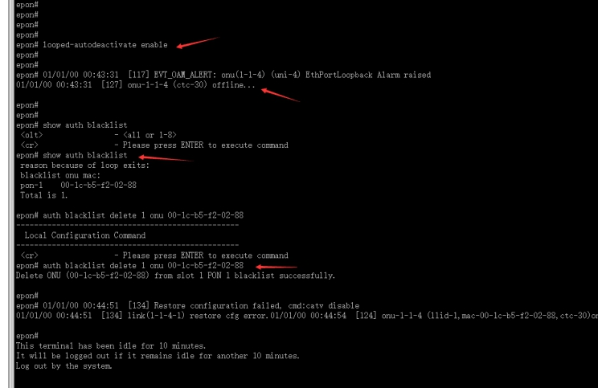

2. Add deadlock-detect command.
Before you have an issue that ONU offline but show online on OLT. When the issue happens again, please use this command. It will help us to find the reason.
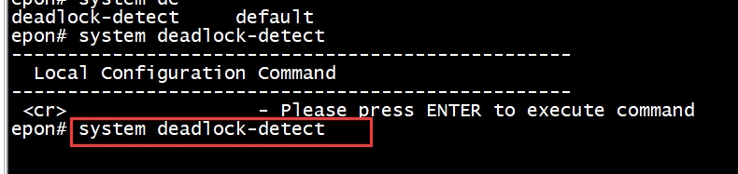

3.solve issue: cpu ultilization high because of loop-detect feature.
4.solve issue that onu offline suddenly
5.add captcha on web and recognize capital and lower-case letter.
6.search ONU id based on ONU mac.
7.add syslog feature.

BUG fixex:
1.when apply ONU template to the FD504G-E ONU with model id 417R, the ONU doesn't get configuration like the tamplate.
2.When we configure alarm threshod for ONU, there isn't alarm threshold configuration in show running-config
3.Sometimes, the ONU port vlan config would be lost.
4.limit ONU port rate and save config, but the config would be lost after reboot.
5.system-access control doesn't work
6.Save ACL config and reboot OLT, the configuration would be lost.

Advanced features -
client isolation
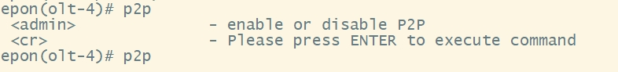

DHCP snooping
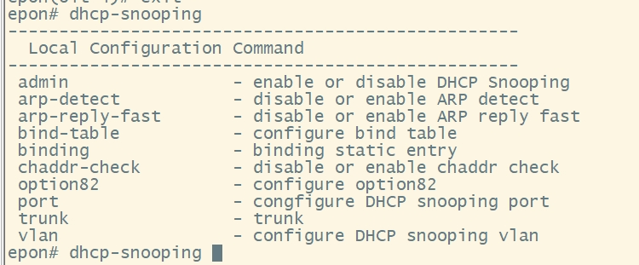

Loop detection
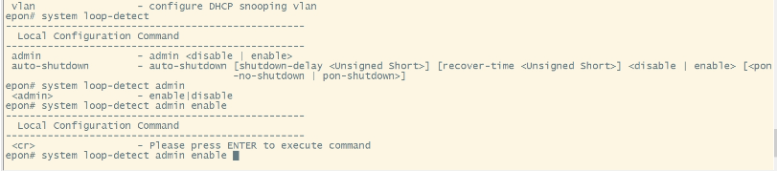

Best wishes,

